CAR RENTAL SYSTEM

A PROJECT REPORT

Submitted by

SADIK HUSAIN (2300100048)
SALAHUDDIN ANSARI (2300102615)
SHAHBAZ ALAM (2300100272)
SAIF KHAN (2300102401)
SAMEEM AHMAD (2300102001)

in partial fulfillment for the award of the degree

of

Bachelor of Computer Application



INTEGRAL UNIVERSITY LUCKNOW

April 2026



CERTIFICATE

Certified that this project report “CAR RENTAL SYSTEM” is the bonafide work of “SADIK HUSAIN, SALAHUDDIN ANSARI, SHAHBAZ ALAM, SAIF KHAN, SAMEEM AHMAD” who carried out the project work under my supervision.

MR. HAMDI SHAKEEL
(Assistant Professor)
Department of Computer Application
Integral University, Lucknow



CERTIFICATE

Certified that this project report “CAR RENTAL SYSTEM” is the bonafide work of “SADIK HUSAIN, SALAHUDDIN ANSARI, SHAHBAZ ALAM, SAIF KHAN, SAMEEM AHMAD” who have successfully carried out the project.

Mr. Sarfaraz Alam Prof. (Dr.) Mohammad Faisal
Project Coordinator Head Department of Computer Application Department of Computer Application
Integral University, Lucknow Integral University, Lucknow

DECLARATION

“I hereby declare that this submission is my own work and that, to the best of my knowledge and belief, it contains no material previously published or written by another person nor material which has been accepted for the award of any other degree or diploma of the university or other institute of higher learning, except where due acknowledgment has been made in the text”.

Date:
Sadik Husain

Salahuddin Ansari

Shahbaz Alam

Saif Khan

Sameem Ahmad

Acknowledgement

We would like to express our sincere gratitude to all those who have contributed to the completion of this project. First and foremost, we extend our heartfelt appreciation to our project coordinator Mr. Sarfaraz Alam, for their invaluable guidance, support, and encouragement throughout this project. Their insights and expertise have been instrumental in shaping this project. We are also grateful to Dr. Mohammad Faisal, Head of the Department, Department of Computer Application, for their constant support and encouragement.

We would also like to express our deep gratitude to our faculty of lab, Mr. Obaidullah Khan, Mr. Mohd Shabbir and project guide, Mr. Hamdi Shakeel.

We would also like to acknowledge the contribution of the developers and contributors of the open-source tools and libraries used in this project, without which this project would not have been possible. Finally, we would like to thank our families for their understanding, patience, and unwavering support throughout this project.

TABLE OF CONTENTS

CHAPTERS PAGE NO

Chapter 1: Introduction ........................................ 1
1.1 Introduction to Car Rental System
1.2 Objectives of the Project
1.3 Scope of the Project
1.4 Technology Used

Chapter 2: Problem Identification & Feasibility Study .... 5
2.1 Problem Definition
2.2 Existing System Issues
2.3 Proposed System
2.4 Feasibility Study (Technical, Economic, Operational)

Chapter 3: Requirement Analysis .............................. 10
3.1 Functional Requirements
3.2 Non-Functional Requirements
3.3 Hardware Requirements
3.4 Software Requirements

Chapter 4: Review of Previous Work ......................... 15
4.1 Existing Car Rental Systems
4.2 Limitations of Existing Systems
4.3 Improvements in Proposed System

Chapter 5: Project Description ............................... 20
5.1 Overview of System
5.2 Modules Description
5.3 User Roles (Admin, Customer)
5.4 System Features

Chapter 6: System Design ..................................... 25
6.1 Context Diagram
6.2 Data Flow Diagrams (DFD Level 0, Level 1)
6.3 Entity Relationship Diagram (ERD)
6.4 Flowchart
6.5 Database Design (Tables & Schema)
6.6 Snapshots of Project Interface

Chapter 7: Conclusion & Future Scope ...................... 40
7.1 Conclusion
7.2 Future Enhancements

📎 SUPPLEMENTARY SECTIONS
References ......................................................... 42
Appendices .......................................................... 43
Appendix 1: Source Code
Appendix 2: Database Queries
Appendix 3: Additional Screenshots
Bio-data of Group Members .................................. 45

ABSTRACT

The Car Rental System is a web-based application developed to automate and streamline the process of vehicle rental services for both customers and administrators. The rapid growth of digital technologies and increasing demand for convenient transportation solutions have created a need for efficient and user-friendly rental systems. This project aims to provide an integrated platform that simplifies the traditional car rental process through digital transformation.
The system enables users to register and securely log into the platform, where they can browse available vehicles, view detailed information such as model, pricing, features, and availability status, and make bookings according to their requirements. The application is designed to provide a seamless and efficient user experience, allowing customers to complete the entire rental process online without the need for physical interaction. Additionally, the system maintains booking records, allowing users to view their rental history and manage their reservations effectively.
From an administrative perspective, the system provides comprehensive control over all operations. The administrator can manage vehicle inventory by adding new cars, updating existing records, and removing unavailable vehicles. Furthermore, the admin module allows efficient handling of customer data, booking information, and transaction records. This centralized management system significantly reduces manual workload, minimizes errors, and enhances operational efficiency.
The Car Rental System is developed using modern web technologies, ensuring reliability, scalability, and security. Proper authentication and validation mechanisms are implemented to protect user data and maintain system integrity. The system also follows a responsive design approach, making it accessible across various devices, including desktops, tablets, and smartphones.

One of the major advantages of this system is its ability to save time and improve efficiency. Customers can easily access the platform at any time and from any location, eliminating the need to visit rental offices or wait in queues. On the other hand, rental service providers benefit from automated processes, better record management, and improved customer service. The system also supports better decision-making by providing accurate and organized data.
Moreover, the project has the potential for further enhancements, such as integration of online payment gateways, GPS-based vehicle tracking, automated billing systems, and notification services through email or SMS. These features can further increase the usability and effectiveness of the system.
In conclusion, the Car Rental System serves as a practical and efficient solution for modernizing vehicle rental services. It not only enhances customer convenience but also improves business operations through automation and digital management. This project highlights the importance of web-based applications in solving real-world problems and contributes to the advancement of technology-driven service systems.

KEY HIGHLIGHTS :
- Web-based automated rental management system
- Secure user registration and login system
- Easy car browsing and booking functionality
- Admin control for managing cars and users
- Real-time availability tracking
- Reduces paperwork and manual errors
- Saves time for both users and administrators
- Responsive and user-friendly interface
- Scalable and secure system design
- Future scope includes payment integration and GPS tracking

CHAPTER 1: INTRODUCTION
1.1 Introduction to Car Rental System
The Car Rental System is a web-based or software-based application designed to manage the renting of cars in an efficient, automated, and user-friendly manner. In traditional car rental services, customers usually have to visit rental offices, check availability manually, fill out paperwork, and wait for confirmation. This process is time-consuming and less efficient.
The Car Rental System solves these problems by providing a digital platform where users can easily search for available cars, compare different models, check rental prices, and book vehicles online from anywhere at any time. It also allows administrators or rental companies to manage their fleet of cars, track bookings, update availability status, and handle customer records efficiently.
This system improves transparency, reduces manual errors, and enhances customer satisfaction by providing quick access to services. It is especially useful in modern urban environments where people prefer online services for convenience and speed.

1.2 Objectives of the Project
The main objective of the Car Rental System project is to develop an efficient and automated platform that simplifies the process of renting vehicles. The system aims to eliminate manual work and provide a smooth experience for both customers and administrators.
Key objectives include:
- To provide an easy-to-use online platform for car booking and rental services.
- To allow users to search and filter cars based on their requirements such as price, type, and availability.
- To maintain a centralized database for storing customer details, booking information, and vehicle records.
- To reduce paperwork and manual intervention in the rental process.
- To improve the efficiency of car rental management by automating tasks like booking confirmation, availability tracking, and return management.
- To enhance customer satisfaction by providing fast, reliable, and transparent services.
- To ensure data security and proper authentication of users and administrators.
Overall, the objective is to digitalize the traditional car rental process and make it more convenient and reliable.

1.3 Scope of the Project
The scope of the Car Rental System is wide and can be expanded in many directions depending on the requirements of the organization or business. This system is not limited to just booking cars but can be extended to manage a complete vehicle rental business.
The system can be used by:
- Individual customers who want to rent cars for personal or business use.
- Car rental companies to manage their entire fleet of vehicles.
- Travel agencies that provide transportation services.
- Corporate organizations for employee transport services.
Future scope of the project includes:
- Integration of online payment gateways for secure transactions.
- Mobile application development for Android and iOS platforms.
- GPS tracking system for rented vehicles.
- AI-based recommendation system for suggesting suitable cars to users.
- Real-time availability updates and dynamic pricing features.
Thus, the system has strong scalability and can be upgraded with modern technologies to meet future demands.

1.4 Technology Used
The Car Rental System can be developed using a combination of front-end, back-end, and database technologies to ensure smooth functionality and user experience.
Common technologies used in this project include:
Frontend Technologies:
- HTML (HyperText Markup Language) – for structuring web pages
- CSS (Cascading Style Sheets) – for designing and styling the user interface
- JavaScript – for adding interactivity and dynamic features
Backend Technologies:
- PHP / Node.js / Java / Python (any one depending on implementation)
- Used for server-side processing, logic handling, and database communication
Database:
- MySQL / MongoDB
- Used to store user data, car details, bookings, and transaction records
Development Tools:
- Visual Studio Code / Sublime Text – for coding
- XAMPP / WAMP – for local server environment
- Browser (Chrome/Edge) – for testing the application
Additional Technologies (Optional):
- Bootstrap – for responsive design
- AJAX – for real-time data updates without page refresh
- APIs – for payment gateways or map integration
By using these technologies, the Car Rental System becomes efficient, scalable, and user-friendly.

CHAPTER 2: PROBLEM IDENTIFICATION & FEASIBILITY STUDY

2.1 Problem Definition
The Car Rental System is designed to solve the problems faced in traditional vehicle rental processes. In the manual system, customers often face difficulties in checking car availability, comparing prices, and booking vehicles. Most of the operations are performed using paper-based records or basic offline methods, which are slow and inefficient.
The main problem is the lack of a centralized and automated system that can manage all rental activities in one platform. Customers need to physically visit rental offices or make phone calls to book a car, which leads to delays and miscommunication. Additionally, maintaining records manually increases the chances of errors, duplication of data, and loss of important information.
Therefore, the problem definition focuses on creating a digital Car Rental System that allows users to search, book, and manage rental cars easily while enabling administrators to efficiently manage the fleet and booking records.

2.2 Existing System Issues
The existing manual or semi-automated car rental systems have several limitations and problems:
- Manual Record Keeping: All data related to customers, bookings, and vehicles is maintained manually, which is time-consuming and error-prone.
- Lack of Real-Time Availability: Customers cannot instantly check whether a car is available or not.
- Delay in Booking Process: The booking process takes more time due to paperwork and manual approval.
- Data Inconsistency: There is a high chance of duplicate or incorrect data entry.
- Poor Customer Experience: Customers need to physically visit offices or make phone calls for inquiries and bookings.
- Difficulty in Managing Fleet: Managing multiple vehicles and tracking their usage becomes complex for administrators.
- No Centralized System: Data is scattered and not stored in a unified database, making retrieval difficult.
These issues reduce efficiency and make the system outdated in today’s digital environment.

2.3 Proposed System
The proposed Car Rental System is a web-based application that automates the entire car rental process. It provides a centralized platform where users and administrators can interact efficiently.
Key Features of Proposed System:
- Users can register and log in to the system securely.
- Customers can search for available cars based on type, price, and availability.
- Online booking system allows users to reserve cars instantly.
- Admin panel to manage cars, bookings, and customers.
- Automatic update of car availability after booking or return.
- Better security through authentication and database management.
- User-friendly interface for smooth navigation.
Advantages of Proposed System:
- Fast and efficient booking process
- Reduced manual errors
- Improved data accuracy and security
- Real-time updates on car availability
- Better customer satisfaction
- Easy management for administrators
The proposed system aims to replace the traditional manual system with a fully automated and efficient digital solution.

2.4 Feasibility Study
A feasibility study is conducted to determine whether the proposed system is practical and beneficial in terms of technical, economic, and operational aspects.

(a) Technical Feasibility
Technical feasibility checks whether the required technology is available and suitable for developing the system.
- The system can be developed using technologies like HTML, CSS, JavaScript, PHP/Node.js, and MySQL.
- These technologies are widely available and easy to implement.
- Developers can easily build, test, and deploy the system using standard tools like Visual Studio Code and XAMPP.
- Internet connectivity and basic hardware are sufficient to run the system.
Conclusion: The project is technically feasible because all required technologies are accessible and well-supported.

(b) Economic Feasibility
Economic feasibility evaluates whether the project is cost-effective.
- The development cost is low because most tools used are open-source (e.g., MySQL, PHP, Node.js).
- No expensive hardware or software is required.
- Maintenance cost is also minimal.
- It reduces operational costs by eliminating manual paperwork and labor.
Conclusion: The system is economically feasible as it provides high benefits at low cost.

(c) Operational Feasibility
Operational feasibility checks whether the system is easy to use and operate.
- The system is user-friendly and designed for both customers and administrators.
- Users with basic computer knowledge can easily operate it.
- It reduces dependency on manual work and improves operational efficiency.
- Training requirements are minimal due to simple interface design.
Conclusion: The system is operationally feasible as it is easy to use and improves overall workflow efficiency.

CHAPTER 3: REQUIREMENT ANALYSIS
Requirement Analysis is the process of identifying what the system should do and what resources are needed to develop and run the system properly. It helps to understand the needs of users and define the features and limitations of the system clearly before development starts.

3.1 Functional Requirements
Functional requirements describe the main functions and features that the Car Rental System must perform. These are the services that the system provides to the users and administrators.
In the Car Rental System, functional requirements include:
- The system should allow users to register and create an account.
- Users should be able to log in securely using username and password.
- The system should allow users to search for available cars.
- Users should be able to view car details such as model, price, type, and availability.
- The system should allow users to book a car for a specific date and time.
- The system should update car availability automatically after booking.
- Users should be able to cancel or modify bookings if needed.
- The system should generate booking confirmation for users.
- Admin should be able to add new cars to the system.
- Admin should be able to update or delete car information.
- Admin should manage customer details and bookings.
- The system should store all data in a database securely.
These functions ensure that the system works smoothly and fulfills the needs of both users and administrators.

3.2 Non-Functional Requirements
Non-functional requirements define how the system should perform rather than what it should do. These requirements focus on quality, performance, and reliability of the system.
In the Car Rental System, non-functional requirements include:
- Performance: The system should respond quickly to user requests without delay.
- Security: User data and login information should be secure and protected from unauthorized access.
- Reliability: The system should work without frequent errors or crashes.
- Usability: The interface should be simple and easy to use for all users.
- Scalability: The system should be able to handle an increasing number of users and bookings in the future.
- Maintainability: The system should be easy to update and maintain when required.
- Availability: The system should be available for users most of the time without downtime.
These requirements ensure that the system is efficient, stable, and user-friendly.

3.3 Hardware Requirements
Hardware requirements refer to the physical devices needed to develop and run the Car Rental System properly.
For development and usage, the following hardware is required:
- Processor: Minimum Intel Core i3 or higher
- RAM: At least 4 GB (8 GB recommended for better performance)
- Hard Disk: Minimum 500 GB storage space
- Monitor: Standard display monitor (HD recommended)
- Keyboard and Mouse: For input and navigation
- Server Machine (Optional for hosting): For running the system online
- Internet Connection: Required for online access and database communication
These hardware components are sufficient to run and test the system efficiently.

3.4 Software Requirements
Software requirements refer to the programs and tools needed to develop and operate the Car Rental System.
The required software includes:
- Operating System: Windows 10/11, Linux, or macOS
- Frontend Technologies:
  - HTML (for structure)
  - CSS (for design)
  - JavaScript (for interactivity)
- Backend Technology:
  - PHP / Node.js / Python (depending on project choice)
- Database:
  - MySQL or MongoDB for storing data
- Web Server:
  - XAMPP / WAMP / Apache Server
- Code Editor:
  - Visual Studio Code or Sublime Text
- Browser:
  - Google Chrome / Microsoft Edge for testing
These software tools help in building, running, and managing the Car Rental System efficiently.

CHAPTER 4: REVIEW OF PREVIOUS WORK
In this chapter, we study the existing car rental systems that are already used in the market. We also identify their limitations and explain how our proposed system improves them. This helps in understanding why a new system is needed and how it is better than the old systems.

4.1 Existing Car Rental Systems
Existing car rental systems are already available in both manual and online forms. Many car rental companies use websites or software applications to manage their services.
Some common features of existing systems include:
- Online car booking through websites or mobile apps.
- Display of available cars with details like price, model, and type.
- Customer registration and login systems.
- Basic booking and payment options.
- Admin panel for managing cars and bookings.
Examples of existing car rental services include popular platforms like Zoomcar, Revv, and local rental agencies that use basic software systems.
However, many small or local car rental businesses still use manual systems, where bookings are done through phone calls, WhatsApp, or physical visits.

4.2 Limitations of Existing Systems
Although existing systems provide some digital facilities, they still have several limitations:
- Complex User Interface: Some systems are not user-friendly and are difficult for beginners to use.
- Limited Features: Many systems do not provide advanced features like real-time tracking or dynamic pricing.
- Slow Performance: Some websites or applications load slowly due to heavy traffic or poor design.
- Security Issues: Not all systems have strong security measures for user data protection.
- Limited Customization: Users cannot easily filter or customize their search options.
- Dependence on Internet: If the internet is slow or unavailable, users cannot access the system properly.
- High Cost for Small Businesses: Some advanced systems are expensive for small rental companies.
Because of these limitations, there is still a need for a more efficient, simple, and cost-effective system.

4.3 Improvements in Proposed System
The proposed Car Rental System is designed to overcome the limitations of existing systems and provide a better user experience.
Key Improvements:
- Simple and User-Friendly Interface: The system is easy to use for both beginners and experienced users.
- Faster Performance: The system is optimized for quick loading and smooth operation.
- Better Security: User data and booking information are protected using secure login and database management.
- Real-Time Updates: Car availability is updated instantly after booking or return.
- Improved Search Options: Users can easily filter cars based on price, type, and availability.
- Automated System: Reduces manual work and human errors in booking and management.
- Cost-Effective Solution: Designed using open-source tools, making it affordable for small businesses.
- Better Data Management: All information is stored in a centralized database for easy access and management.
Conclusion:
The proposed system provides a modern, efficient, and reliable solution compared to existing systems. It improves speed, accuracy, security, and user satisfaction, making it suitable for both customers and car rental companies.

CHAPTER 5: PROJECT DESCRIPTION
This chapter provides a clear description of the Car Rental System project. It explains how the system works, what modules are included, who can use the system, and what features are available. It gives a complete understanding of the project structure and working.

5.1 Overview of System
The Car Rental System is a web-based application designed to make the process of renting cars easy, fast, and efficient. It allows users to search, view, and book cars online without visiting a physical office.
The system connects customers and car rental administrators on a single platform. Customers can browse available cars, check details, and make bookings. At the same time, administrators can manage cars, bookings, and user data.
The main purpose of this system is to replace manual booking methods with a digital solution that saves time, reduces errors, and improves customer satisfaction.
The system works in a simple flow:
- User logs in → searches cars → selects car → books car → gets confirmation
- Admin logs in → manages cars → manages bookings → updates availability

5.2 Modules Description
The Car Rental System is divided into different modules. Each module has a specific function and works together to complete the system.
1. User Module
- Allows customers to register and log in.
- Users can search for cars based on their needs.
- Users can view car details like price, model, and availability.
- Users can book and cancel cars.
2. Car Management Module
- Admin can add new cars to the system.
- Admin can update car details such as price, type, and status.
- Admin can remove cars that are not available.
3. Booking Module
- Handles all booking operations.
- Stores booking details in the database.
- Updates car availability automatically after booking or cancellation.
4. Admin Module
- Admin can manage users and their bookings.
- Admin can approve or reject booking requests.
- Admin can monitor system activity.
5. Database Module
- Stores all data such as user information, car details, and booking records.
- Ensures data is safe and easily accessible.

5.3 User Roles (Admin, Customer)
The system has two main types of users:
1. Admin (Administrator)
The admin is the main controller of the system. Admin responsibilities include:
- Managing cars in the system.
- Adding, updating, and deleting car records.
- Managing customer accounts and bookings.
- Monitoring system performance.
- Ensuring smooth operation of the system.
2. Customer (User)
The customer is the person who rents the car. Customer responsibilities and features include:
- Registering and logging into the system.
- Searching for available cars.
- Viewing car details and prices.
- Booking cars for a specific time period.
- Canceling or modifying bookings if needed.
Both roles are important for the smooth functioning of the Car Rental System.

5.4 System Features
The Car Rental System provides many useful features to improve user experience and system efficiency.
Main Features:
- User Registration and Login: Secure authentication for users and admin.
- Car Search Function: Easy search based on car type, price, and availability.
- Online Booking System: Users can book cars anytime from anywhere.
- Real-Time Availability: Updated information about available cars.
- Admin Dashboard: Full control for managing cars and bookings.
- Database Management: Secure storage of all data.
- Booking Confirmation: Instant confirmation after successful booking.
- Simple User Interface: Easy and clean design for better usability.
- Fast Performance: Quick response time for all operations.
- Secure System: Protects user data and login credentials.

Conclusion:
The Car Rental System is a complete solution for managing car rentals digitally. It simplifies the booking process, reduces manual work, and improves efficiency for both customers and administrators.

CHAPTER 6: SYSTEM DESIGN
System Design is the most important phase of the project. In this phase, we define how the system will work, how data will flow, how different components are connected, and how the database will store information. It helps to convert the idea into a proper working model.

6.1 Context Diagram
A Context Diagram shows the overall view of the system. It represents the Car Rental System as a single process and shows how it interacts with external users like Admin and Customer.
In this diagram:
- The Customer sends requests such as searching cars, booking cars, and viewing details.
- The Admin manages cars, users, and bookings.
- The System processes all requests and provides responses.
👉 Simply, it shows:
Customer ↔ Car Rental System ↔ Admin
It helps to understand the boundary of the system and its interaction with outside users.

6.2 Data Flow Diagrams (DFD Level 0, Level 1)
DFD Level 0 (High-Level View)
DFD Level 0 shows the main process of the system as a single process.
- Customer sends request → System processes request → System gives output (booking confirmation, car details)
- Admin sends updates → System stores data in database
It represents the basic flow between users and system.

DFD Level 1 (Detailed View)
DFD Level 1 breaks the system into smaller processes:
Main Processes:
- Search Car Process
  - User searches available cars
  - System fetches data from database
- Booking Process
  - User selects car and books it
  - System stores booking details
- User Management Process
  - Admin manages user accounts
- Car Management Process
  - Admin adds, updates, or deletes car details
- Payment (Optional Process)
  - Handles payment information if included
This level gives a clear understanding of how each function works internally.

6.3 Entity Relationship Diagram (ERD)
ERD shows how different entities (tables) are connected in the database.
Main Entities:
- User
- Admin
- Car
- Booking
- Payment (optional)
Relationships:
- One User can make many Bookings
- One Car can be booked many times (at different times)
- Admin manages all cars and bookings
👉 Example:
- User (User_ID, Name, Email, Password)
- Car (Car_ID, Model, Type, Price, Status)
- Booking (Booking_ID, User_ID, Car_ID, Date, Status)
ERD helps in designing a proper database structure without confusion.

6.4 Flowchart
A Flowchart shows step-by-step working of the system.
Customer Flow:
Start → Login/Register → Search Car → Select Car → Book Car → Confirmation → End
Admin Flow:
Start → Login → Manage Cars → View Bookings → Update Status → End
Flowchart helps to visually understand the working process of the system.

6.5 Database Design (Tables & Schema)
Database design defines how data is stored in tables.
1. User Table
- User_ID (Primary Key)
- Name
- Email
- Password
- Phone
2. Car Table
- Car_ID (Primary Key)
- Car_Name
- Model
- Type
- Price_per_day
- Availability_Status
3. Booking Table
- Booking_ID (Primary Key)
- User_ID (Foreign Key)
- Car_ID (Foreign Key)
- Booking_Date
- Return_Date
- Status
4. Admin Table
- Admin_ID
- Username
- Password
5. Payment Table (Optional)
- Payment_ID
- Booking_ID
- Amount
- Payment_Status
This database structure helps in storing and retrieving data efficiently.

6.6 Snapshots of Project Interface
This section contains screenshots of the actual working system.
Common Screenshots include:
- Home Page
- User Registration Page
- Login Page
- Car Listing Page
- Car Booking Page
- Admin Dashboard
- Booking Management Page

Snapshot 1: Home Page (Hero Section)
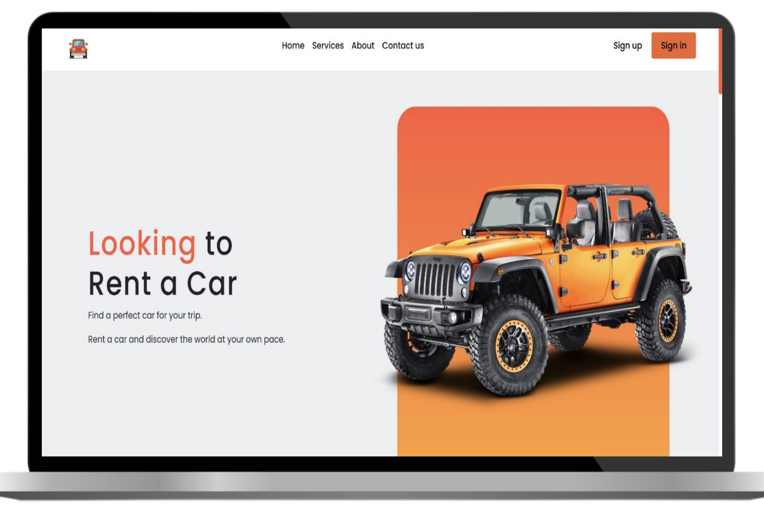The Home Page serves as the primary entry point for users, featuring a modern and minimalist design aimed at enhancing user engagement.
- Header & Navigation: The top section includes a professional logo followed by navigation links: Home, Services, About, and Contact us.
- User Access: Distinct buttons for Sign up and a highlighted Sign in button are placed on the far right to streamline the authentication process.
- Visual Identity: The right side of the layout features a high-resolution image of a Jeep Wrangler set against a geometric orange backdrop, creating a vibrant and professional aesthetic.
- Core Messaging: The left side contains the main heading—"Looking to Rent a Car"—supported by descriptive subtext that encourages users to explore and book vehicles for their trips.
- Design Palette: The interface utilizes a clean white background with bold orange accents, ensuring high readability and a contemporary feel.

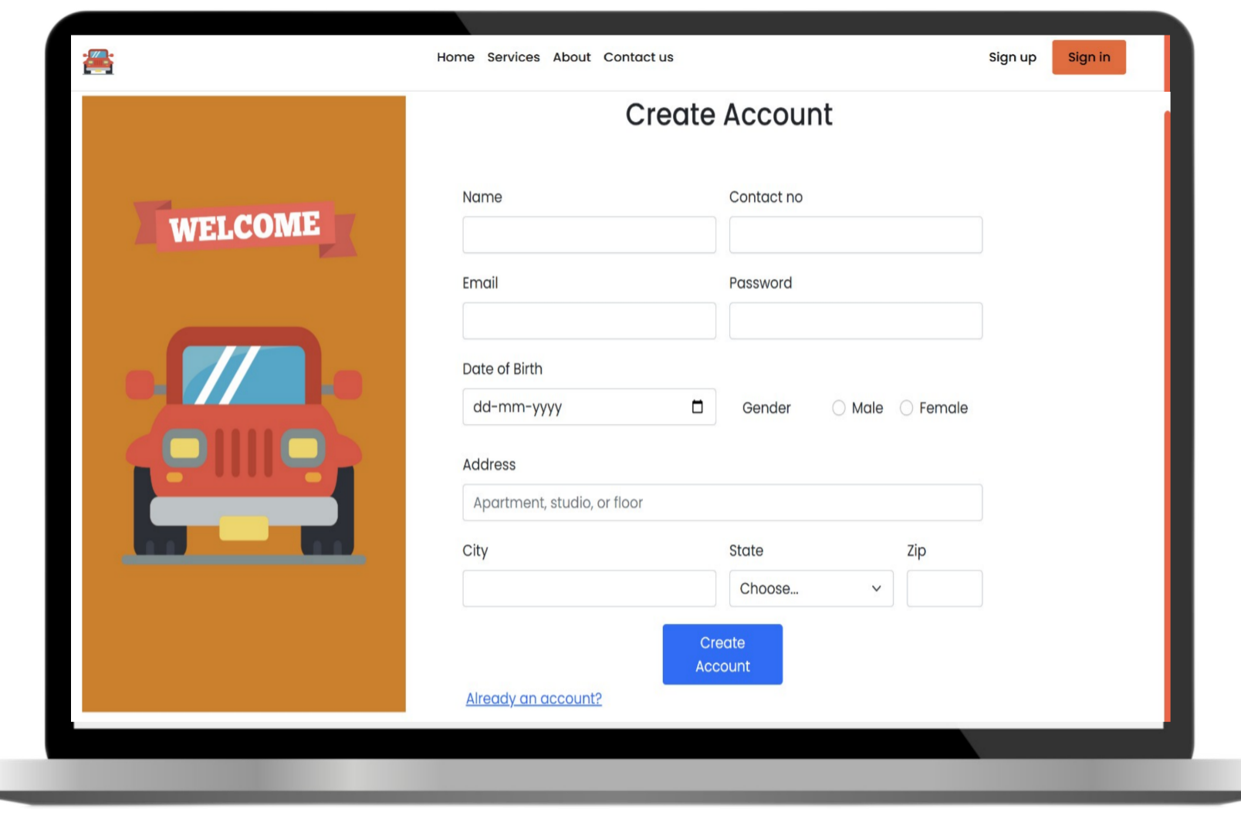
Snapshot 2: User Registration Page
The User Registration Page is designed to capture necessary user details to create a secure account within the system.
- Side Illustration: The left panel features a "Welcome" banner with a stylized car illustration on an orange background, maintaining brand consistency with the home page.
- Comprehensive Data Entry: The form includes multiple input fields for a complete user profile:
  - Personal Info: Name, Contact Number, Email, and Password.
  - Identity Details: Date of Birth (with a date picker) and Gender selection (Male/Female radio buttons).
  - Location Details: Detailed address fields including Apartment/Studio, City, State (dropdown), and Zip code.
- Action Elements: A prominent blue "Create Account" button is positioned at the bottom to submit the form.
- User Redirection: An "Already have an account?" link is provided at the bottom to allow existing users to navigate back to the Login Page easily.

Snapshot 3: Login Page
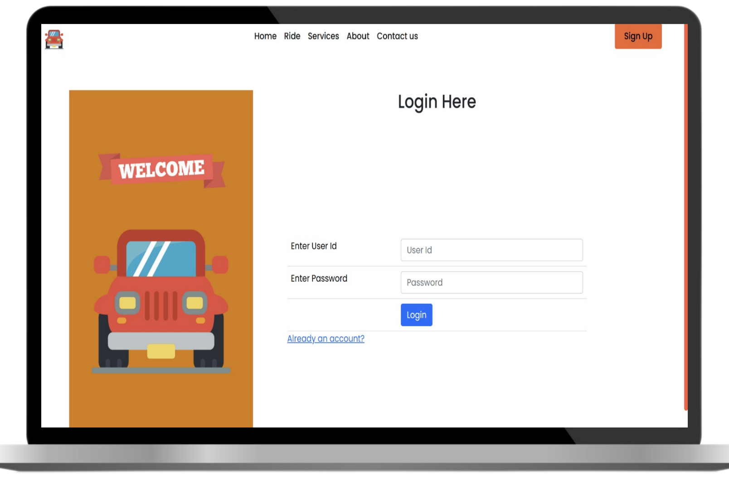
The Login Page provides a secure gateway for registered users and administrators to access their accounts.
- Consistent Branding: The left panel mirrors the registration page with a "Welcome" banner and a stylized car illustration on an orange background to maintain visual harmony.
- Authentication Form: A clean and centered form titled "Login Here" captures the necessary credentials:
  - User Id: A dedicated input field for the user's unique identification.
  - Password: A secure input field for the account password.
- Action Elements: A prominent blue "Login" button is used to submit the credentials for verification.
- Navigation Links: For ease of use, an "Already an account?" link is provided (though typically used for registration, it maintains the layout's symmetry) and a "Sign Up" button remains visible in the header for new users.

Snapshot 4: Car Listing Page
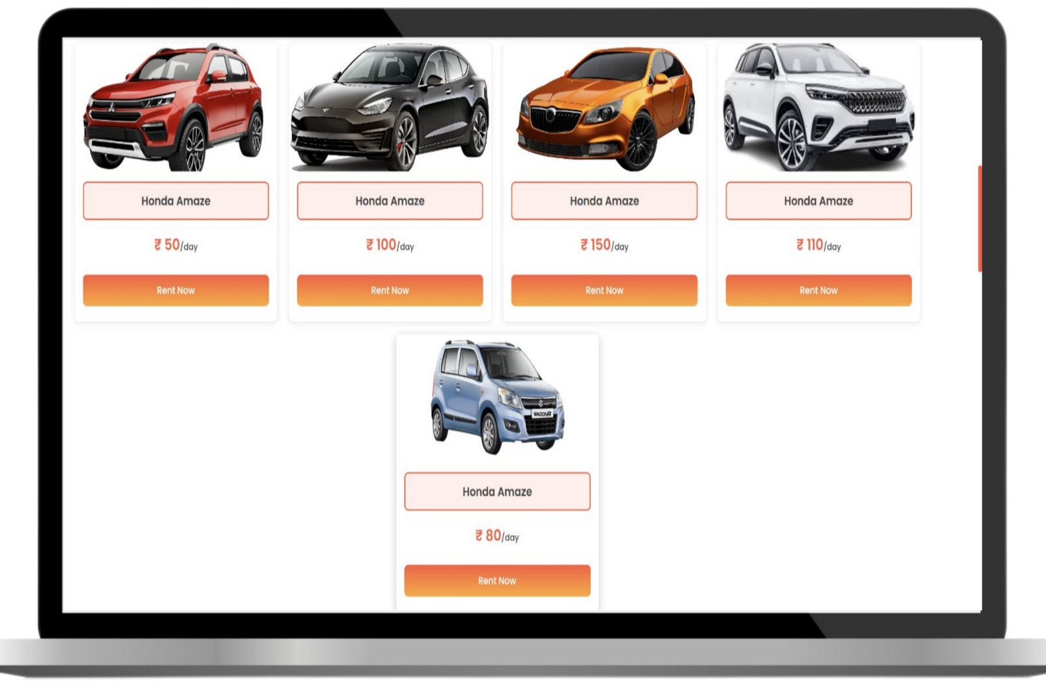
The Car Listing Page acts as the digital showroom of the system, displaying the variety of vehicles available for rent.
- Grid Layout: The page uses a clean responsive grid system to display multiple car options simultaneously, making it easy for users to compare choices.
- Car Cards: Each vehicle is presented in an individual card containing:
  - Vehicle Image: A high-quality preview of the car.
  - Model Name: The specific name/brand of the vehicle (currently shown as "Honda Amaze" across the placeholders).
  - Pricing: The rental cost per day is clearly displayed in a bold orange font (e.g., ₹ 50/day, ₹ 100/day).
- Call to Action: Every card features a prominent orange gradient "Rent Now" button, which directs the user to the booking or details page for that specific vehicle.
- Visual Consistency: The page maintains the project's signature white and orange color palette, providing a seamless transition from the Home and Login pages.

Snapshot 5: Car Booking Page
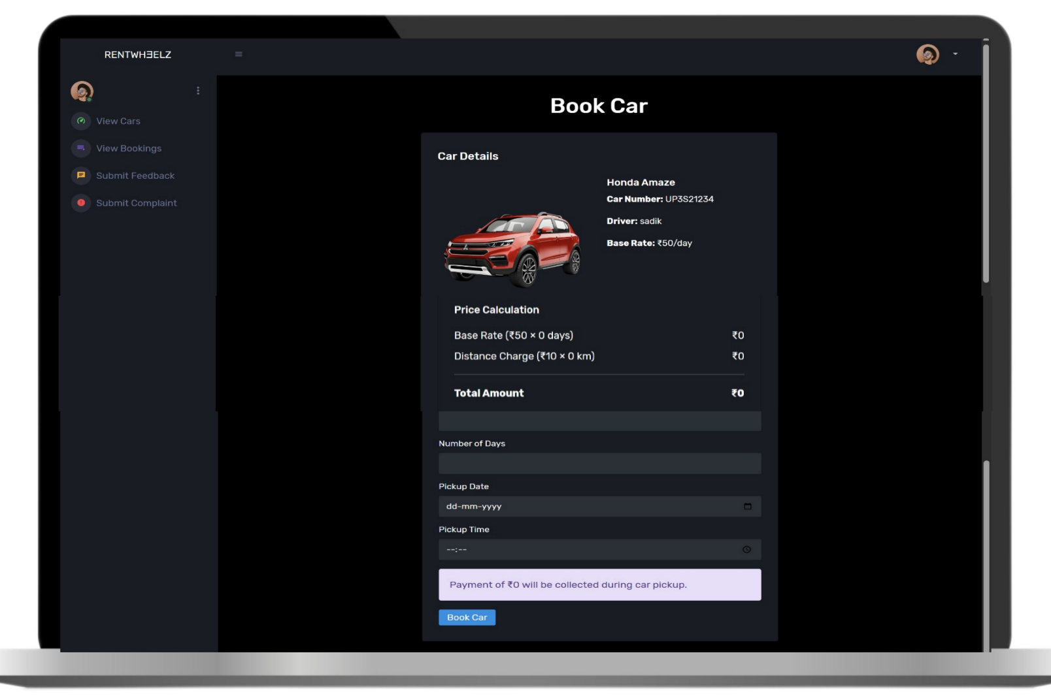
The Car Booking Page is a critical functional component where users input their rental requirements and view the final cost breakdown.
- Vehicle Summary: The top section displays the selected car's details, including the Model Name (Honda Amaze), Car Number, assigned Driver, and the Base Rate per day.
- Dynamic Price Calculation: This section provides a transparent breakdown of costs, showing the Base Rate multiplied by the number of days and any applicable Distance Charges.
- Booking Form: Users are required to fill in essential scheduling information:
  - Number of Days: To calculate the total rental duration.
  - Pickup Date: A date picker for scheduling the start of the trip.
  - Pickup Time: A time input for precise coordination.
- Payment Information: A highlighted notification informs the user of the final amount to be collected during car pickup, ensuring clarity on the payment process.
- Sidebar Navigation: The page includes a functional sidebar (labeled RENTWHEELZ) allowing users to quickly navigate to other sections like View Cars, View Bookings, or Submit Feedback.

Snapshot 6: Admin Dashboard
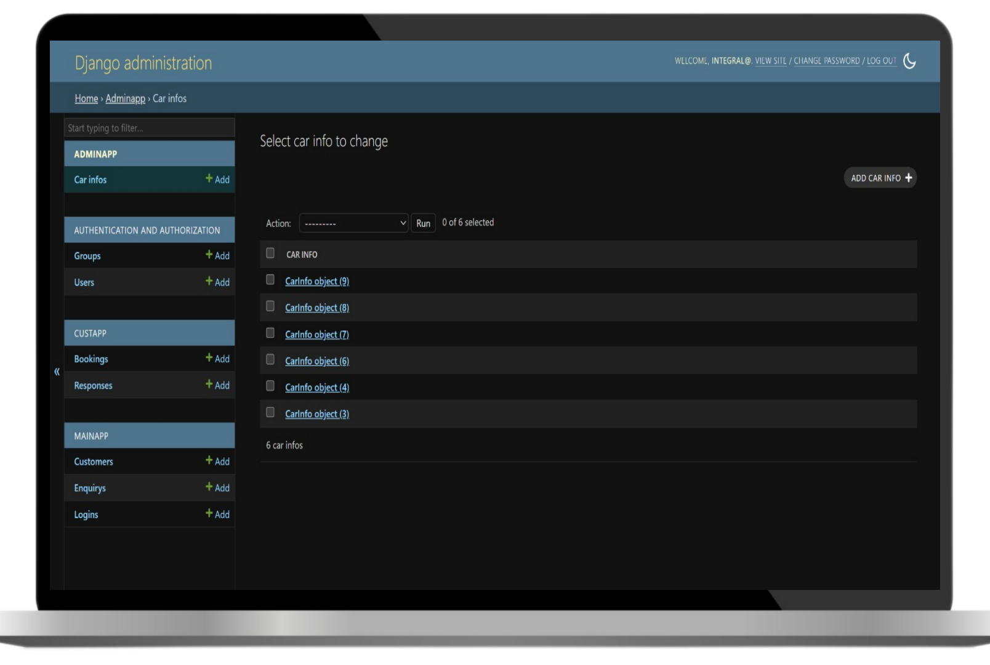
The Admin Dashboard provides a comprehensive interface for administrators to manage the backend data and core functionalities of the Car Rental System.
- Django Administration Backend: The interface uses the robust Django framework for data management, as indicated by the header.
- Navigation Sidebar: A structured sidebar organizes the system into distinct modules for easy access:
  - Admin App: Specifically manages "Car Infos" (vehicle details).
  - Authentication: Manages user Groups and individual User accounts.
  - Custapp & Mainapp: Dedicated sections for managing Bookings, Responses, Customers, and Enquiries.
- Data Management: The central area displays the "Select car info to change" screen, which allows the admin to:
  - View a list of all existing car objects in the database.
  - Perform bulk actions (Delete/Update) using the Action dropdown.
  - Add new vehicle entries using the prominent "ADD CAR INFO +" button.
- Admin Status Bar: The top right corner displays the active admin user, options to change passwords, and a toggle for Dark Mode (which is currently active in this snapshot).

Snapshot 7: Booking Management Page
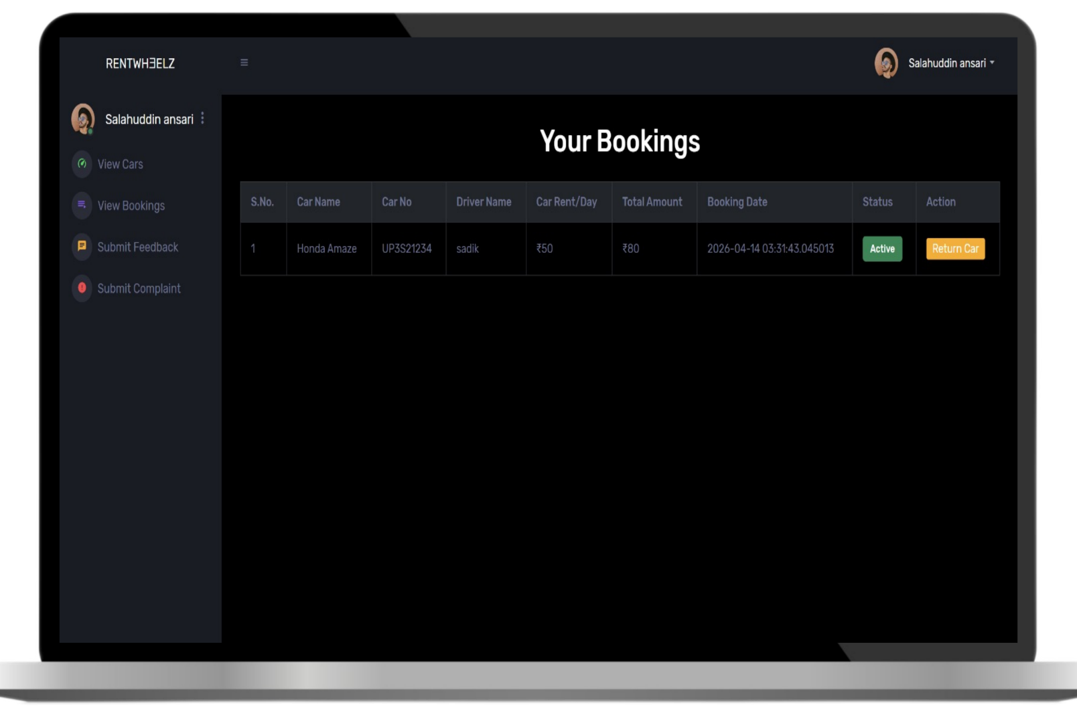
The Booking Management Page provides users with a clear overview of their current and past rental activities, ensuring transparency and ease of control.
- User Dashboard Interface: The page features a consistent dark-themed sidebar containing navigation options such as View Cars, View Bookings, Submit Feedback, and Submit Complaint.
- Personalized Header: The top right corner displays the logged-in user's profile (Salahuddin ansari), adding a personalized touch to the system interface.
- Bookings Table: All rental data is organized in a detailed tabular format with the following columns:
  - Car Details: Shows the Car Name (e.g., Honda Amaze) and Car Number.
  - Rental Info: Includes the Driver Name, Rent per Day, and the calculated Total Amount.
  - Timestamp: Displays the exact Booking Date and time for record-keeping.
- Status & Actions:
  - Status: A green "Active" label indicates the current state of the booking.
  - Action: A prominent orange "Return Car" button allows the user to initiate the return process once the rental period is over.

CHAPTER 7: CONCLUSION & FUTURE SCOPE

7.1 Conclusion
The Car Rental System project is successfully designed to make the process of renting cars simple, fast, and efficient. The main goal of this project is to replace the traditional manual system with a modern computerized system.
In the traditional system, users face many problems such as long waiting time, manual paperwork, and difficulty in checking car availability. These problems are solved by this system through automation and a centralized database.
This system allows users to search for cars, view details, and book them online easily. At the same time, the administrator can manage cars, bookings, and users in an efficient way.
The project improves accuracy, reduces human errors, and saves time for both customers and rental companies. It also provides better security and better data management using a structured database system.
Overall, the Car Rental System is a useful and practical application that improves the working process of car rental services and provides a better user experience.

7.2 Future Enhancements
Although the current system works efficiently, there is always scope for improvement in the future. The system can be enhanced with more advanced features and technologies.
Some possible future improvements include:
- Online Payment Gateway Integration: Users will be able to make payments directly through debit card, credit card, or UPI.
- Mobile Application Development: A mobile app for Android and iOS can make the system more accessible.
- GPS Tracking System: Real-time tracking of rented cars for better safety and monitoring.
- AI-Based Recommendations: The system can suggest cars based on user preferences and past bookings.
- Chatbot Support: 24/7 customer support using AI chatbot for instant help.
- Dynamic Pricing System: Prices can change based on demand, season, or availability.
- Advanced Security Features: Two-factor authentication and better encryption for user data.
- Email and SMS Notifications: Automatic updates for booking confirmation, reminders, and payments.
These enhancements will make the system more powerful, modern, and user-friendly in the future.

📎 SUPPLEMENTARY SECTIONS

References
This section includes the sources used for developing the Car Rental System project:
- Books on Software Engineering and Database Management Systems
- Tutorials on HTML, CSS, JavaScript, and PHP/Node.js
- Online documentation (W3Schools, MDN Web Docs)
- Sample project references from academic websites
- Guidance from project supervisor/teacher

Appendices {{{{{{{{{{{{{
Sure 👍 I’ll explain in Hinglish (simple + easy):

📎 Appendices kya hote hain?
Appendices project report ka last section hota hai jisme hum extra important information add karte hain.
Ye information main chapters me nahi likhi jati, lekin project ko support karti hai.

Appendix 1: Source Code
Is section me aap apne project ka poora programming code likhte ho.
👉 Isme kya hota hai:
- HTML code (front-end design)
- CSS code (design & styling)
- JavaScript code (functions & interactivity)
- PHP / Node.js / Python code (backend logic)
📌 Purpose:
Ye batata hai ki aapka system andar se kaise kaam karta hai.
✔ Example:
- Login page ka code
- Car booking system ka code
- Admin dashboard ka code

Appendix 2: Database Queries
Isme aap apne database ke SQL commands (queries) likhte ho.
👉 Isme hota hai:
- CREATE TABLE (table banane ke liye)
- INSERT (data add karne ke liye)
- SELECT (data dekhne ke liye)
- UPDATE (data change karne ke liye)
- DELETE (data remove karne ke liye)
📌 Purpose:
Ye batata hai ki data system me kaise store aur manage hota hai.
✔ Example:
User table, Car table, Booking table ke queries

Appendix 3: Additional Screenshots
Is section me aap apne project ke screenshots (photos) lagate ho.
👉 Isme hota hai:
- Home page
- Login page
- Car listing page
- Booking page
- Admin dashboard
- Database output screens
📌 Purpose:
Ye proof hota hai ki aapka project actually working hai.

⭐ Simple Summary
- Appendix 1 = Code (project ka andar ka logic)
- Appendix 2 = Database (data ka system)
- Appendix 3 = Screenshots (project ka proof)

✔ Matlab Appendices = Extra supporting details of your project

Agar chaho to main tumhe:
✔ Ready source code (Car Rental System)
✔ Full SQL database file
✔ Ya screenshots ka perfect list (kya-kya capture karna hai)
bhi bana ke de sakta hoon 👍
}}}}}}}}}}}}}}}}

Appendix 1: Source Code
This section includes the complete source code of the project such as:
- Frontend code (HTML, CSS, JavaScript)
- Backend code (PHP / Node.js / Python)
- Login and registration system code
- Booking system code
- Admin dashboard code
(Full code is attached in project folder)

Appendix 2: Database Queries
This section includes SQL queries used in the project:
- CREATE TABLE queries (User, Car, Booking, Admin)
- INSERT queries for sample data
- SELECT queries for fetching records
- UPDATE queries for modifying data
- DELETE queries for removing records
Example:
CREATE TABLE User (
User_ID INT PRIMARY KEY,
Name VARCHAR(100),
Email VARCHAR(100),
Password VARCHAR(100),
Phone VARCHAR(15)
);

Appendix 3: Additional Screenshots
This section contains extra images of the working system, such as:
- Home Page Interface
- Login Page Screenshot
- Car Listing Page
- Booking Confirmation Page
- Admin Dashboard View
- Database Output Screenshots
These screenshots help in understanding the actual working of the system.

Additional Screenshots 1: Home Page
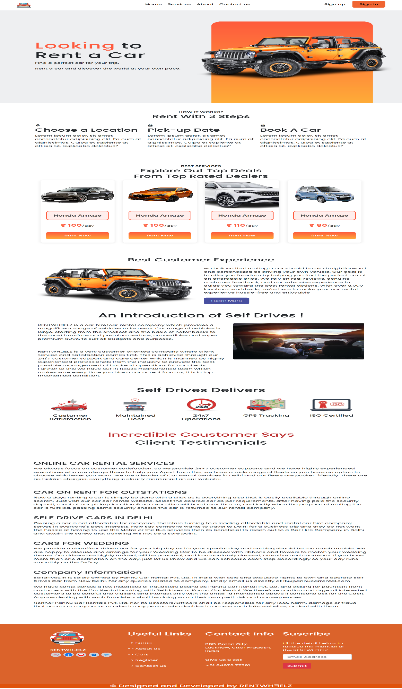

Additional Screenshots 2: Service Page
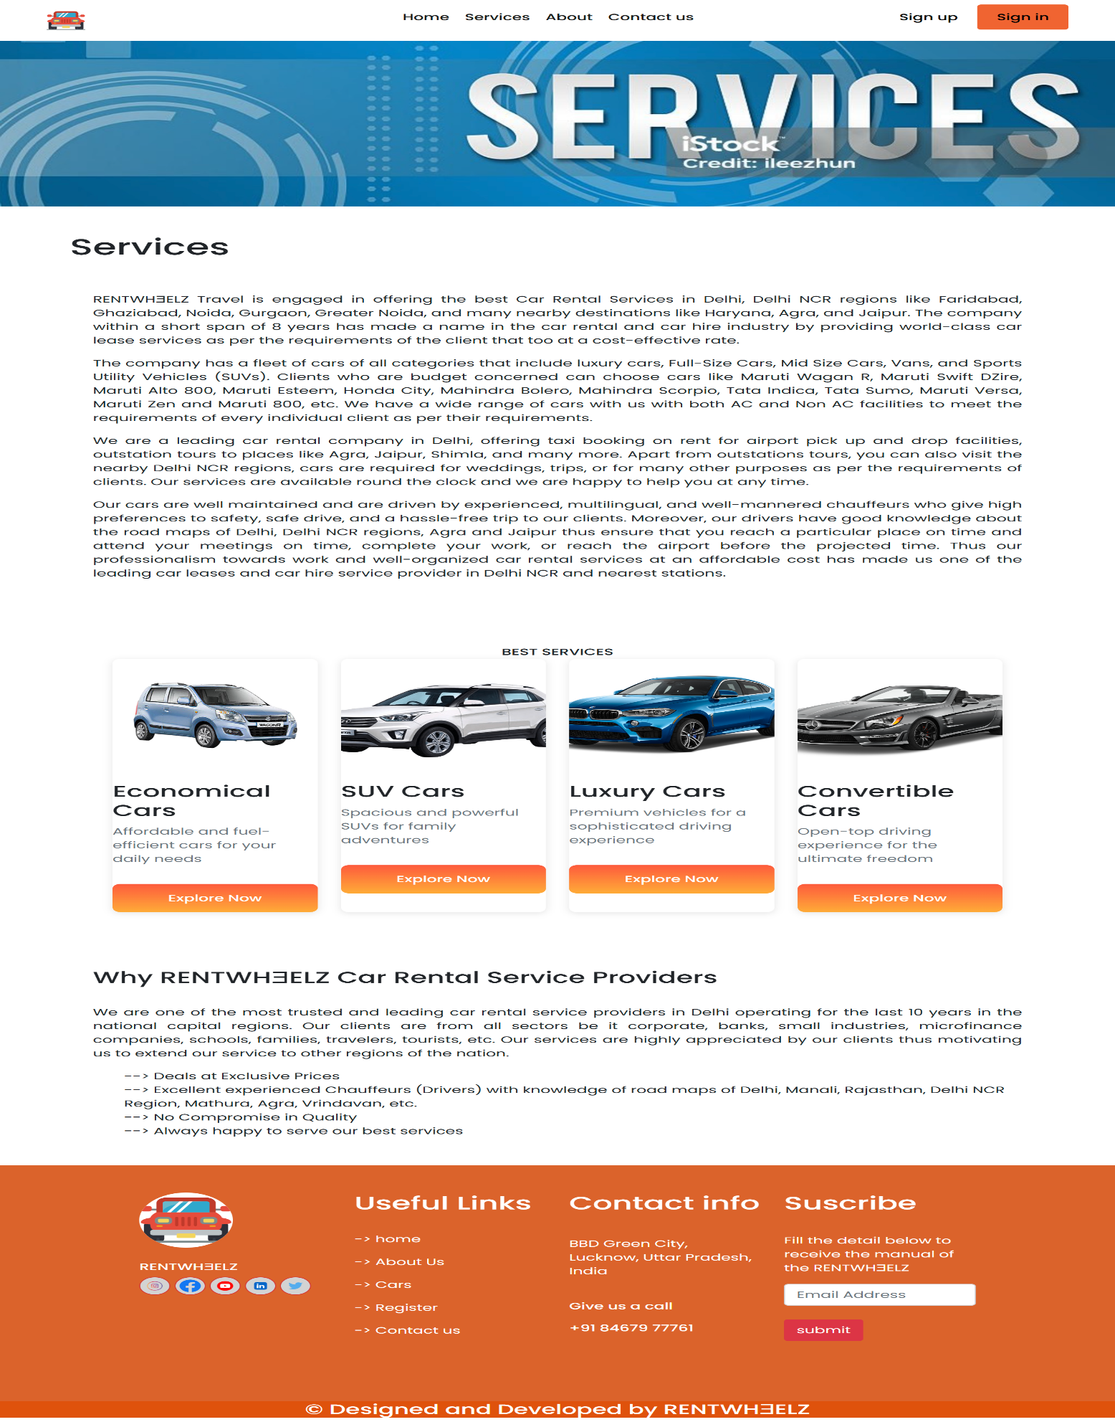
Additional Screenshots 3: About Page

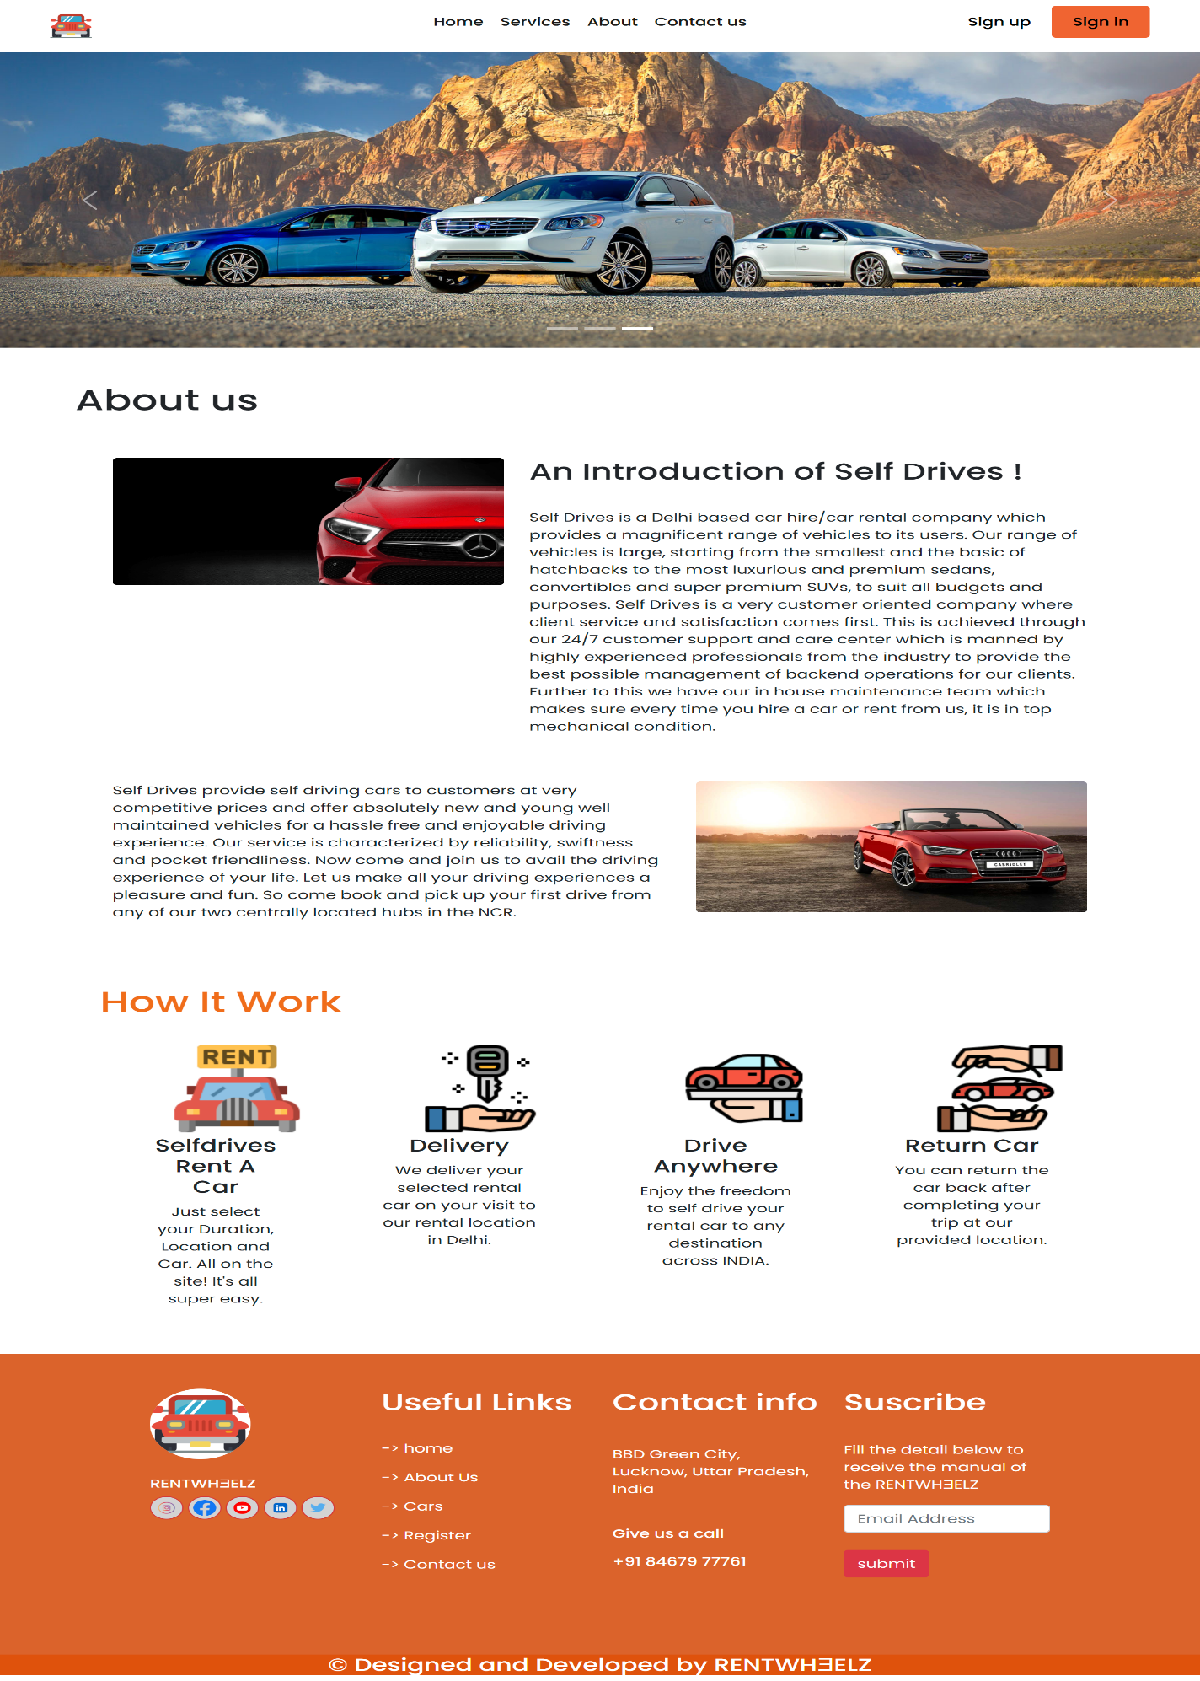
Additional Screenshots 4: Contact us Page

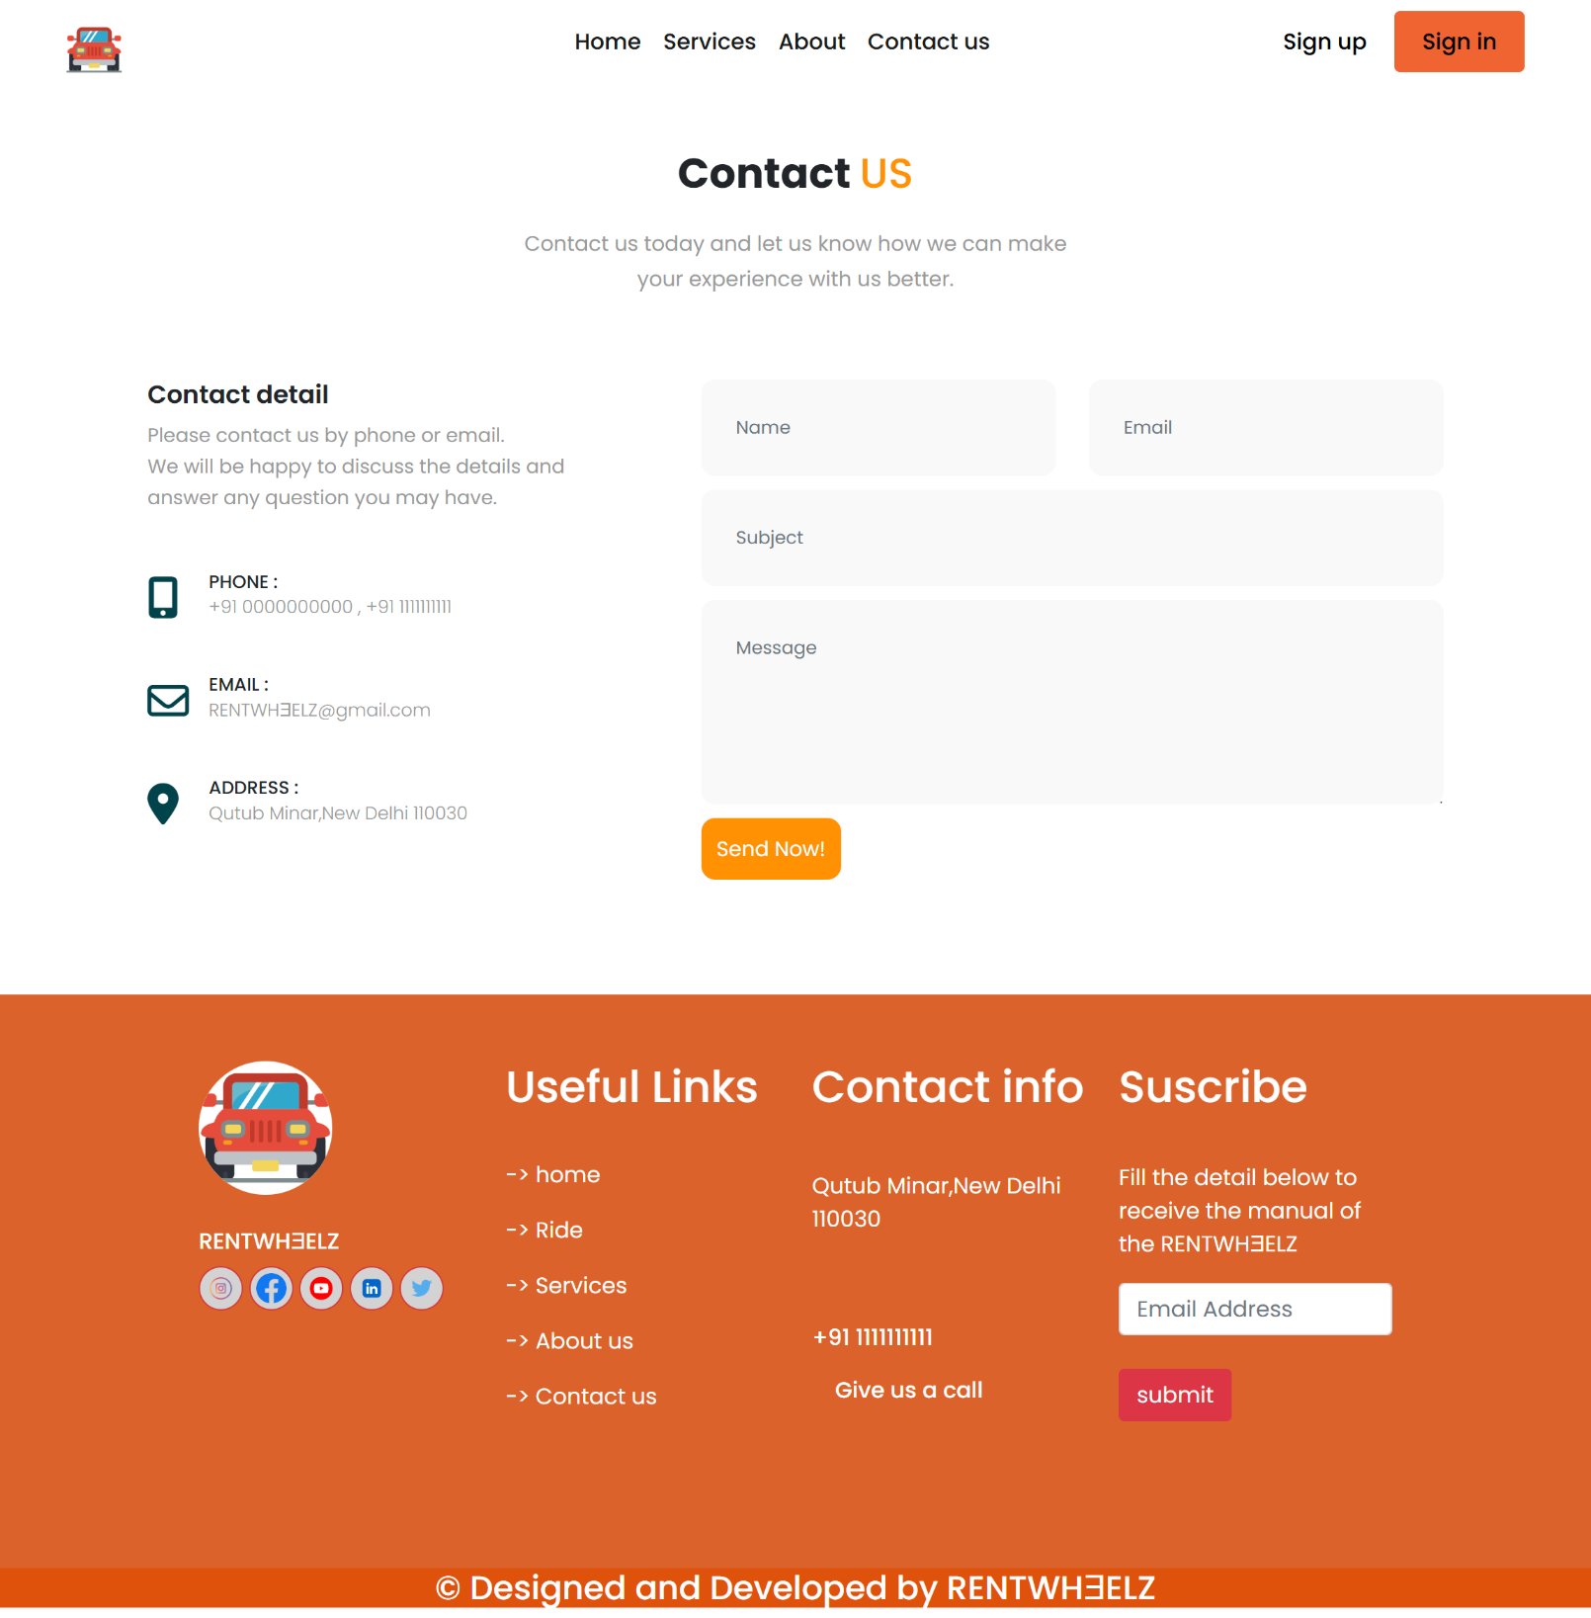

Bio-data of Group Members
This section contains details of all team members who worked on the project.
Example Format:
Name: Salahuddin Ansari
Course: BCA (Bachelor of Computer Applications)
Roll Number: XXXXXXXX
College: Integral University
Role in Project: Frontend Developer / Backend Developer / Documentation
(Repeat same format for other group members)

